Spartan Challenge
Week 1: Madness? This is fitness! (February 3rd – 9th)
AMRAP (as many rounds as possible) 15 mins
- Deadlifts x 5 (M: 135/ F: 95) (M+: 50/ F+ 30)
- Burpees x 10 (M+/F+: Hands can go on a box that is knee height)
- KB Swings x 12 (M: 45/ F: 35) (M+: 35/ F+: 20)

The Male and Female of each category with the most rounds/reps wins!
Please note: M+ and F+ refer to the 55+ years old category

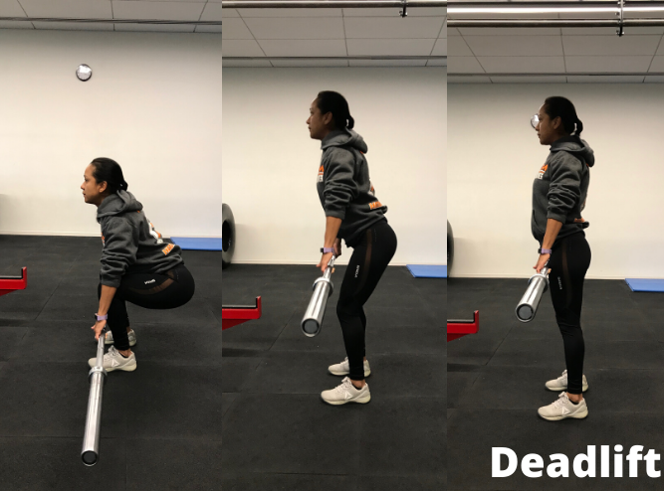 | 