Week 2: The Spartan Mindset
Endurance/Long distance (Must complete 20 minute in one session/can’t break 20 mins into 10 and 10 etc. BUT can do the run and row separately)
- 20 Mins on Air Runner (M+/F+ Use the elliptical)
- 20 Mins on the Rower
Participants with the greatest total distance of meters and miles win
PLEASE NOTE: M+/F+ is a category for 55+ only! (Participants 55+ do not have to compete in this category)

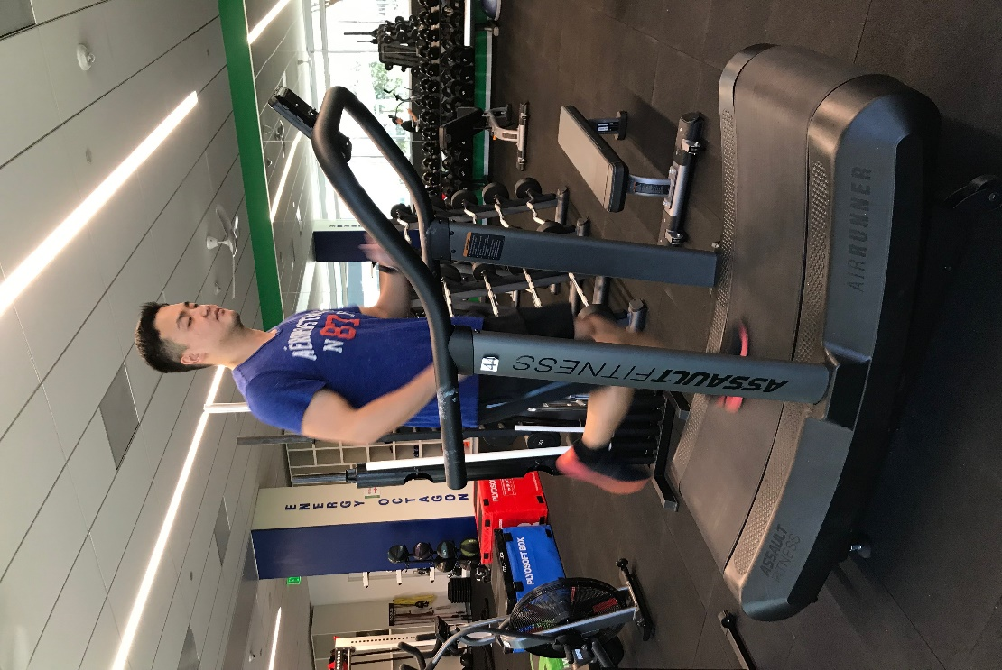 | 