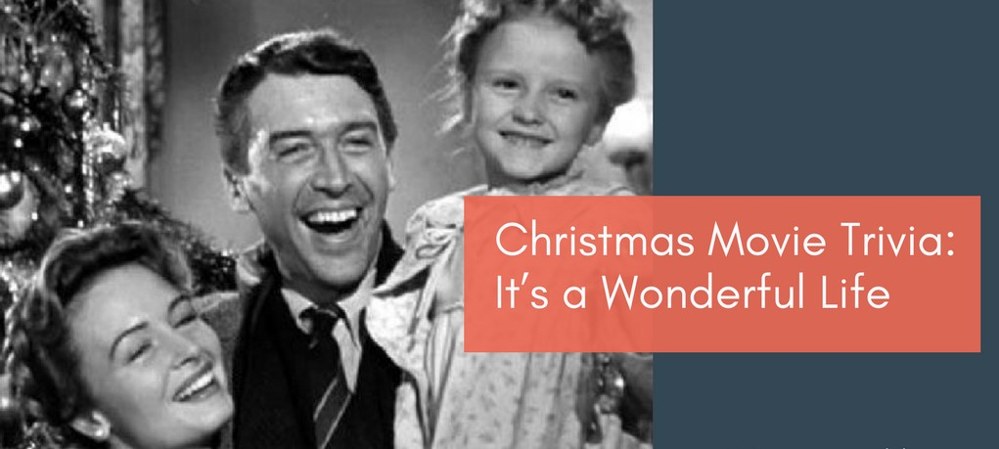

- Who played the main character, George Bailey, in "It's a Wonderful Life"?_______________
- What fictional town is the setting for most of the film? _______________

- In the movie, what is the name of George Bailey's guardian angel? _______________

- What is the name of the savings and loan association that George works for? _______________

- In the alternate reality where George was never born, what is the town of Bedford Falls renamed? _______________

- What is the name of the antagonist in the film, the greedy banker who causes trouble for George? _______________

- What is the name of George Bailey's wife? _______________
- What is the name of the movie theater in Bedford Falls where George and Mary share their first kiss? _______________

- What is the pivotal moment in the film when George wishes he had never been born? _______________

- What is the significance of the bell on the Christmas tree at the end of the film? _______________

Name When Completed:

