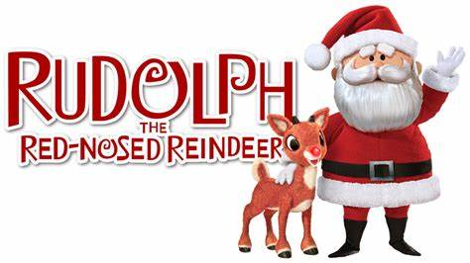
Workout

+Warm-Up (5-10 minutes)

1. Reindeer Prances: (Jog in place, lifting your knees high to your chest) - 2 mins

2. Hermey's Stretch: (Shoulder Circles and Wrist Circles) - 2 mins

3. Bumble's Roar: (Standing forward bends and gentle backbends to loosen up the spine) - 2 mins

Workout (20-30 minutes)

Circuit 1: Yukon Cornelius (Repeat 3x before moving on)

1. 15 Gold Digging Squats: (Squat with a forward punch at the bottom of each squat)

2. 10 each leg Prospector Lunges: (Alternating lunges forward)

3. 10 Iceberg Jumps: (Box Jumps or Step Ups)

Circuit 2: Island of Misfit Toys Routine (Repeat 3x before moving on)

1. 1 min Toy Train Planks: (Plank position moving laterally like a train)

2. 20 Doll Twists: (Russian Twists)

3. 20 Elephant Flies: (Jumping Jacks mimicking elephant ears with arms)

Circuit 3: Rudolph's Flight School (Repeat 3x before moving on)

1. 15 each leg Reindeer Kicks (Donkey Kicks)

2. 10 Sleigh Push-Ups w/Taps: (Push-Ups with a shoulder tap at the top of each rep)

3. 10 Nosedive Burpees (Burpees with a jump at the top to mimic flying)

Cool Down (5-10 minutes)

1. 5 min Misfit Yoga Stretch: (A series of gentle yoga stretches to cool down)

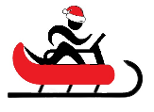
2. 5 min Clarice's Calmness: (Deep Breathing and relaxation)
Name When Completed:

