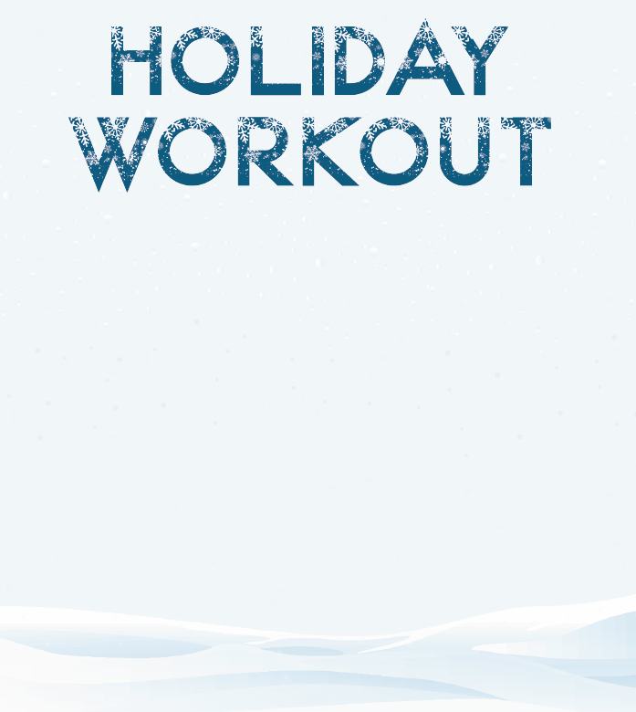

**ABC**

**Name When Completed:**

(Check Mark the Week You Completed)

* **Week 1: GRAVY TRAIN RACERS**
* **Week 2: SNICKERDOODLELICIOUS**
* **Week 3: COUCH GOBBLER**
* **Week 4: TURKEY COMA RECOVERY**
* **Week 5: PRANCE LIKE YOU MEAN IT**
* **Week 6: ROLLIN IN THE DOUGH**
* **Week 7: JINGLE ALL THE WEIGHTS**
* **Week 8: MERRY MUSCLE XMAS**

r