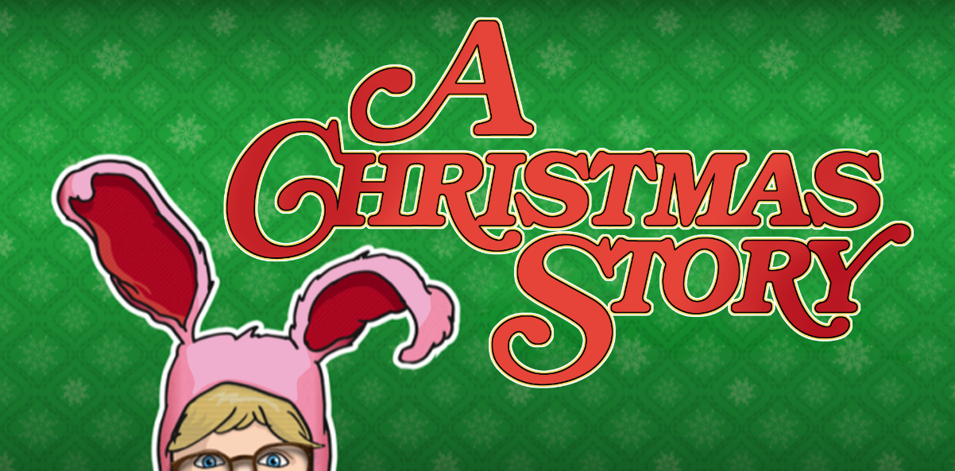

Trivia

- Which Christmas Carol plays in the opening of the movie? _______________

- What is the one thing Ralphie wants for Christmas more than anything else? _______________

- What is the name of Ralphie's little brother? _______________

- What does Ralphie's father win in a contest, causing him to exclaim, "It's a major award!"? _______________

- What happens to Ralphie when he says the bad word while helping his father change a flat tire? _______________

- What is the name of the bullies who torment Ralphie and his friends throughout the movie? _______________

- What food in the final scene does Ralphie's family enjoy for Christmas dinner? _______________

- What does Ralphie imagine when he finally decodes the secret message from Little Orphan Annie's radio show? _______________

- What does Ralphie's mother make him wear as he heads off to school after the bullies steal his hat? _______________

- What happens to Ralphie after he receives his gun for Christmas? _______________
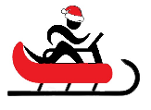
Name When Completed:

