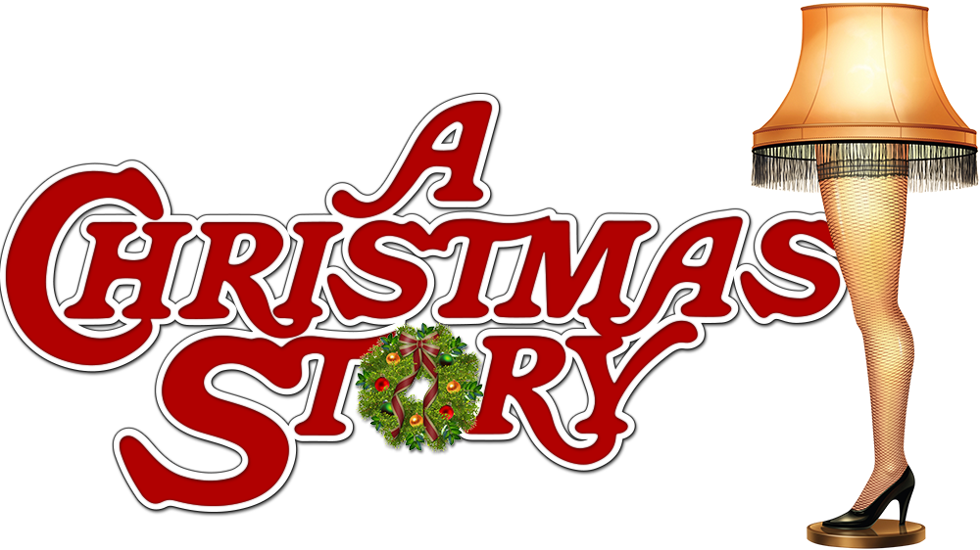

Workout

Warm Up (Repeat 2-3x):

1. Ralphie's Warm Up Run: Go for a 10-minute jog or brisk walk, recalling Ralphie's quest for his Red Ryder BB gun.

2. Tongue Stuck to Pole Stretch: Find a wall or sturdy surface to do a 30 sec. standing calf stretch while imagining someone's tongue getting stuck to a frozen pole.

Main Workout (Repeat 2-3x):

3. Red Ryder Jumping Jacks: Begin with 25 jumping jacks to warm up those muscles, just like Ralphie would jump with excitement for his Red Ryder BB gun.

4. Leg Lamp Lunges: Do 15 forward lunges each side, pretending you're the Old Man, admiring his "major award."

5. Triple Dog Dare Push-Ups: Challenge yourself with 12 push-ups, imagining you're Flick, who famously took on the triple dog dare.

6. Snowball Fight Squats: Perform 20 squats, pretending you're engaged in a friendly snowball fight like Ralphie and his friends.

7. Bunny Suit Burpees: Complete 10 burpees, as if you're getting in and out of Ralphie's pink bunny suit.

8. Christmas Tree Plank: Hold a plank 30 sec., envisioning the family's struggle to set up the Christmas tree.

9. Dad's Award-Winning Turkey Leg Lifts: Lie on your back and do 15 leg lifts while picturing the turkey that the Old Man won as a prize.

10. BB Gun Russian Twists – Sit on the ground, lift your legs, and perform 30 Russian twists, passing a "BB gun" (or a weight) from side to side.

Cool Down:

11. Caroling Cool Down: Finish with some deep breaths and light stretches while humming your favorite Christmas carols from the movie.
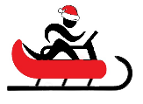
Name When Completed:

