**Staff Workout:**

**Martina**

**Thoracic Cable Rotation**

**(2 x 10 each)**

**Bird Dogs**

**(3 x 10-12 each)**

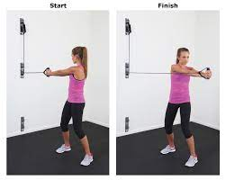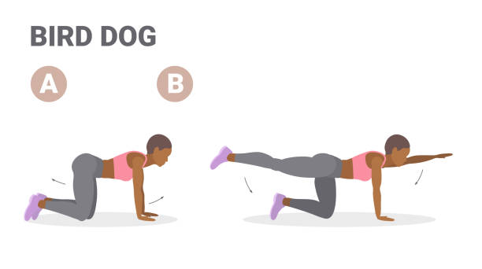

**DB Heels-Elevated Squats**

**(3 x 8-10 each)**

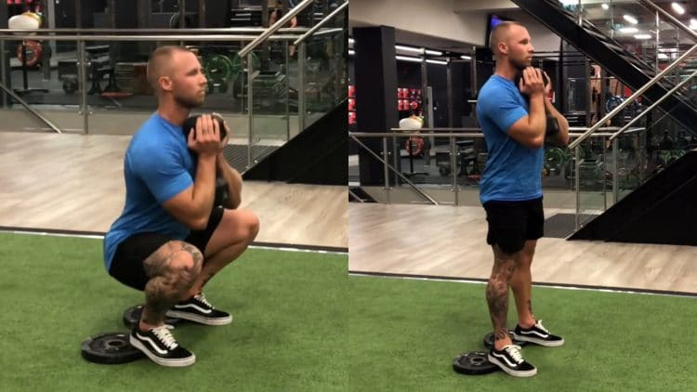

**Quadruped Shoulder Taps**

**(3 x 10 each)**

*(Knees off ground)*

**BW Hamstring Curl w/ Ball**

**(3 x 8-10 each)**

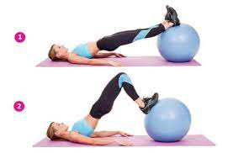

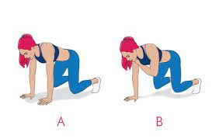

**Incline Treadmill Walk 20 min.**

**(high incline, low-medium speed)**

**Name When Completed:**