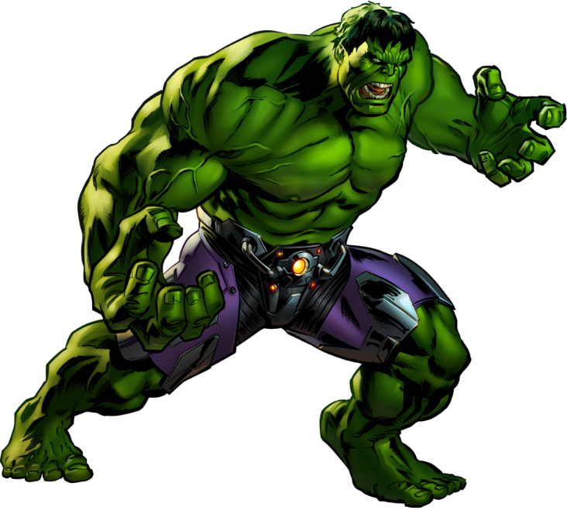

Welcome, brave souls, to the Hulk Smash Workout – a fitness journey that will unleash your inner superhero strength! Channel your inner Hulk as you power through these six exercises designed to sculpt muscles and ignite your power.

1. Gamma Step Up w/Knee Drive: 3 sets of 10 reps each side
- Stand tall and step up on bench with a powerful, Hulk-like knee drive up.

2. Incredible Hulk (Skull Crushers): 3 sets of 10 reps
- Lay on back, dumbbells together above and drop towards skull and lift with a roar, showcasing your might.

3. Smash Kettlebell Swings: 3 sets of 10 reps
- Hold a kettlebell with both hands. Swing it between your legs and then explosively lift it to shoulder height. Control the descent, mimicking the Hulk's smashing prowess.

4. Angry Side Bends: 3 sets of 10 reps each side
-Hold a sumo squat w/arm behind head, bend to the side down to knee.

5. Rampaging Bear Crawls: 3 sets of 20 reps forward
- Get on all fours and crawl forward, keeping your back straight. Move with speed and intensity, like a rampaging Hulk on a mission.

6. Destructive Slams: 3 sets 15 reps
- Pick up a medicine ball and raise it overhead. Slam it to the ground with all your might. Catch and repeat for a smashing cardio boost.

Exercises: | Sets  Reps  Wt. | M | T | W | T | F | S | S
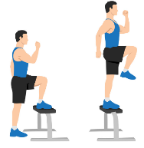  Step Up  w/Knee  Drive | 3 sets
 | 10 reps
 | Wt.
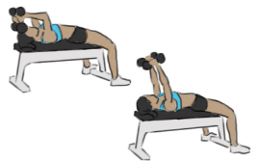  Skull  Crushers | 3 sets
 | 10 reps
 | Wt.
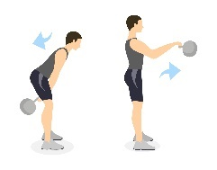  KB  Swing | 3 sets
 | 10 reps
 | Wt.
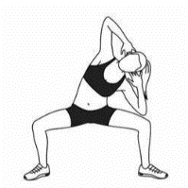  Sumo  Side  Bends | 3 sets
 | 10 reps
 | Wt.
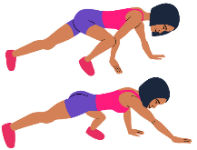  Bear  Crawls | 3 sets
 | 20 reps
 | Wt.
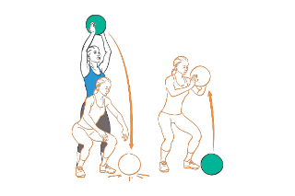  MB Slam  Balls | 3 sets
 | 15 reps
 | Wt.

Congratulations, mighty warrior! You've conquered the Hulk Smash Workout and harnessed the strength of a superhero. Your dedication and power know no bounds. Now, go out into the world and unleash your inner Hulk in every aspect of your life!

Name When Completed:

