Welcome, heroes, to the Flexibility Frenzy Stretching Workout with Mr. Fantastic himself! Just like Reed Richards, the leader of the Fantastic Four, we're about to stretch our limits and unleash our inner elasticity. These stretches will help you reach new lengths, enhance your flexibility, and prepare you for any mission that comes your way.

1. Elastic Arms: 3 sets of Holding 20 sec. each side
-Begin by standing tall with your feet shoulder-width apart. Slowly bring one arm across your chest, using the other hand to gently pull it closer.

2. Fantastic Forward Fold: 3 sets of Holding for 20 sec.
-Stand with your feet hip-width apart. Bend forward at the waist, reaching your hands toward the ground or your shins.

3. Dynamic Spine Twist: 3 sets of Holding for 20 sec. each side
- Sit on the ground. Bend your right knee and cross it over your left leg, placing your right foot on the ground next to your left knee. Twist your torso to the right, placing your left elbow on the outside of your right knee and looking over your right shoulder.

4. Super Stretchy Hamstrings w/Side Bend: 3 sets of Holding for 20 sec. each side
-Sit on the ground with one leg extended straight in front of you and the other leg bent, foot flat on the ground and placed against the inner thigh of the extended leg. Reach forward toward your toes, keeping your back straight. Reach opp. Arm overhead.

5. Incredible Hip Flexor: 3 sets of Holding for 20 sec. each side
-Begin in a low lunge position with your right foot forward and your left knee on the ground. Gently lower your hips toward the ground while keeping your back upright. You should feel a stretch in the front of your left hip.

6. Stretchy Spinal Twist: 3 sets of Holding for 20 sec. each side
-Lie on your back with your knees bent and feet flat on the ground. Extend your arms out to the sides in a T position. Slowly drop your knees to one side, keeping your shoulders on the ground.
Exercises: | Sets  Reps  Wt. | M | T | W | T | F | S | S
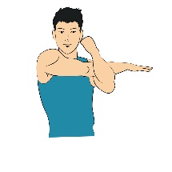  Cross Body  Shoulder | 3 sets
 | 20 sec.
 | Wt.
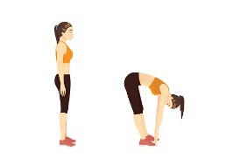  Standing  Hamstring | 3 sets
 | 20 sec.
 | Wt.
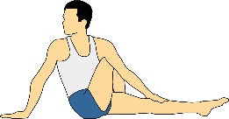  Seated  Spine  Twist | 3 sets
 | 20 sec.
 | Wt.
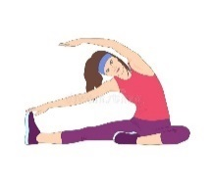  Seated  Hamstring  Side Bend | 3 sets
 | 20 sec.
 | Wt.
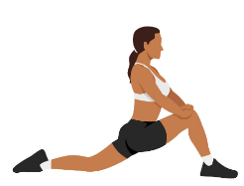  Hip  Flexor | 3 sets
 | 20 sec.
 | Wt.
Laying  Spinal  Twist | 3 sets
 | 20 sec.
 | Wt.

Congratulations, heroes, you've completed the Flexibility Frenzy Stretching Workout! By incorporating these stretches into your routine, you'll enhance your flexibility, improve your range of motion, and feel more agile than ever before. Remember, just like Mr. Fantastic, your flexibility is key to conquering any challenge that comes your way. Keep stretching, stay flexible, and keep saving the day!

Name When Completed:

