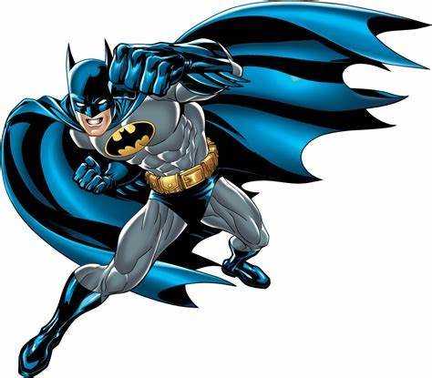
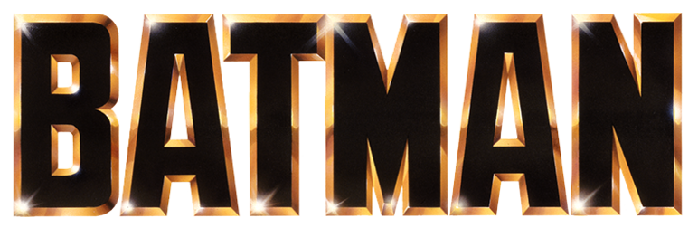

Welcome to the Dark Knight's Vigilante Workout: a training regimen inspired by Batman's legendary strength, agility, and resilience. Channel your inner superhero as you embark on this intense journey to build a physique worthy of Gotham's caped crusader.

1. Gotham City Parkour (Side to Side Jumps): 3 sets of 20 jumps
- Jump from side to side, simulating urban parkour. Embracing the agility required to navigate Gotham's rooftops.

2. Batarang Throws (Medicine Ball Slams): 3 sets of 15 reps
- Grab a medicine ball, raise it overhead, and slam it to the ground with force.

3. Batmobile Push (Sled Push): 3 sets of down and back
- Push a sled loaded with weights across a distance or a towel, mimicking the strength needed to move the Batmobile.

4. Grappling Hook Pull-ups: 3 sets of 10 reps
- Perform pull-ups, imagining you're scaling the side of a building with Batman's trusty grappling hook.

5. Arkham Asylum Core Crunches: 3 sets of 20 reps
- Lie on your back and perform crunches, envisioning the need for a strong core to navigate through Arkham Asylum's challenges.

6. Gotham City Stealth F/B Lunges: 3 sets of 10 each side
- Perform Forward/Backward lunges while focusing on one leg balance and control, honing the stealth required for patrolling Gotham's shadows.
Exercises: | Sets  Reps  Wt. | M | T | W | T | F | S | S
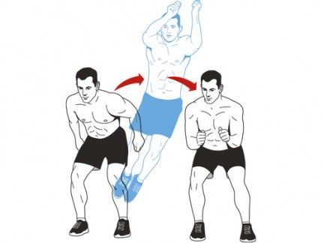  Side to  Side  Jumps | 3 sets
 | 20 reps
 | Wt.
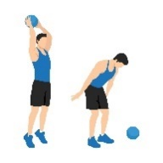  MB Ball  Slams | 3 sets
 | 15 reps
 | Wt.
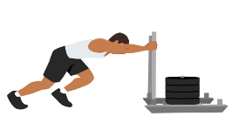  Sled  Push | 3 sets
 | D/B
 | Wt.
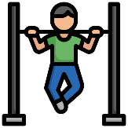  Pull-ups | 3 sets
 | 10 reps
 | Wt.
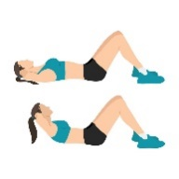  Crunches | 3 sets
 | 20 reps
 | Wt.
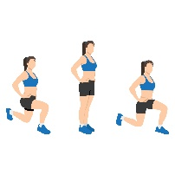  Forward/  Backward  Lunges | 3 sets
 | 10 reps
 | Wt.

Congratulations, Gotham's new protector! You've completed the Dark Knight's Vigilante Workout, embodying the strength and determination of Batman himself. Remember, the journey to superhero status is ongoing – stay committed, stay vigilant. Gotham is counting on you!

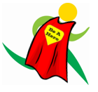
Name When Completed:

