Welcome to Lex Luthor's Diabolical Domination Workout! Prepare to unleash your inner power and dominate like never before. Each exercise is designed to sculpt your body into a weapon of ruthless strength and cunning intellect. Remember, victory belongs to those who are willing to seize it.

1. Power-Hungry Bicep Curls: 3 sets of 15 reps
-Feel the strength surge through your veins as you lift, symbolizing your relentless pursuit of power and control.

2. Kryptonite Sit-up w/ Punches: 3 sets of 10 reps
-Strike fear into the hearts of your enemies as you obliterate your core.

3. Villainous V-Sit Holds: 3 sets of 30 sec.
-Balance on the edge of triumph, embodying the cunning and poise that sets you apart from mere mortals. Hold steady, for victory is within your grasp.

4. Malevolent Split Lunge: 3 sets of 10 reps each side
-Channel your inner rage and frustration into each dip, shattering obstacles and paving the way for your triumph.

5. Tyrant's Tricep Dips: 3 sets of 15 reps
-Command the respect and obedience of all who dare to oppose you, as your arms grow stronger with every descent and ascent.

6. Unpredictable Climb: 3 sets of 3 min.
-Each climb represents a calculated move towards your goal, leaving no stone unturned in your quest for supremacy.

Exercises: | Sets  Reps  Wt. | M | T | W | T | F | S | S
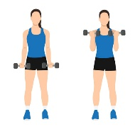  Bicep  Curls | 3 sets
 | 15 reps
 | Wt.
Situp w/  Punches | 3 sets
 | 10 reps
 | Wt.
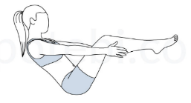  V-Sit  Hold | 3 sets
 | 30 sec.
 | Wt.
Split  Lunge | 3 sets
 | 10 reps
 | Wt.
Tricep  Dips | 3 sets
 | 15 reps
 | Wt.
Stair  Master | 3 sets
 | 3 min
 | Wt.
Congratulations, villainous disciple, on completing Lex Luthor's Diabolical Domination Workout! By embracing the relentless pursuit of power and strength, you have taken another step towards your rightful place at the pinnacle of villainy. Remember, true greatness is earned through perseverance and determination. Now, go forth and conquer, for the world is yours for the taking.

Name When Completed:

