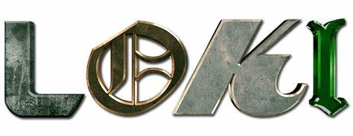

Welcome to the Mischievous Loki Workout, inspired by the infamous God of Mischief himself! Loki, known for his cunning intellect and deceitful ways, has mastered the art of chaos and manipulation. In this workout, we'll channel his villainous energy to push ourselves to new heights of strength and agility.

1. Deceptive Lunges: 3 sets of 20 reps
-Channel Loki's deceptive nature with alternating lunges, keeping your opponent’s guessing with each step forward.

2. Trickster Reverse Fly: 3 sets of 10 reps
-Engage your upper body strength. Just as Loki manipulates the minds of his enemies, manipulate those muscles.

3. Sneaky Spider Curls: 3 sets of 10 reps
-Lay on an incline bench and curl the dumbbells towards your shoulders.

4. Scheming Wall Sit: 3 sets of 30 sec. Hold
-Tap into Loki's cunning mindset with deep squats, imagining yourself plotting your next mischievous scheme as you rise and lower.

5. Sly Toe Touch Crunch: 3 sets of 15 reps
-Engage core and crunch up to toes. Feel the power coursing through you as you conquer each rep, embodying the cunning of Loki.

6. Shadowy Plank Alt. Leg Lifts: 3 sets of 20 reps
Channel Loki's ability to blend into the shadows with shadowy planks.
Exercises: | Sets  Reps  Wt. | M | T | W | T | F | S | S
Alt.  Forward  Lunges | 3 sets
 | 30 sec.
 | Wt.
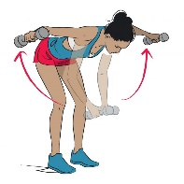  Reverse  Fly | 3 sets
 | 20 reps
 | Wt.
Spider  Curls | 3 sets
 | 15 reps
 | Wt.
Wall Sit | 3 sets
 | 20 reps
 | Wt.
Toe Touch  Crunch | 3 sets
 | 15 reps
 | Wt.
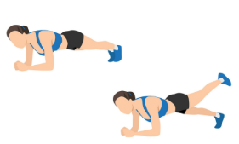  Plank  Alt.  Leg Lifts | 3 sets
 | 15 reps
 | Wt.

Congratulations, fellow trickster, on completing the Mischievous Loki Workout! Just as Loki thrives on chaos and unpredictability, you've embraced the challenge and emerged stronger than ever. Remember, the path to greatness is not always straight and narrow—embrace the twists and turns, and never underestimate the power of a little mischief along the way.

Name When Completed:

