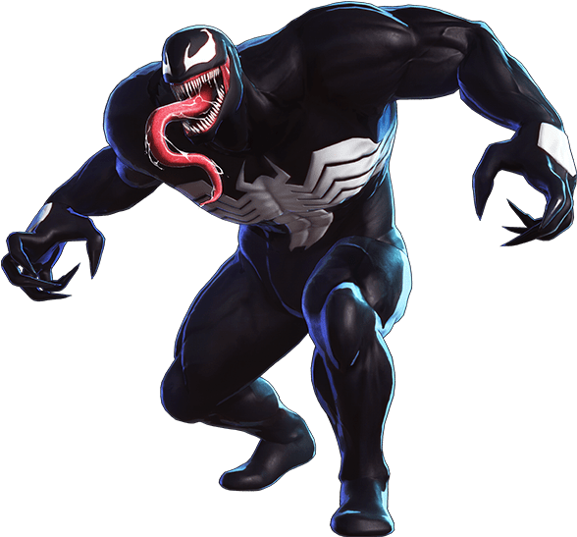
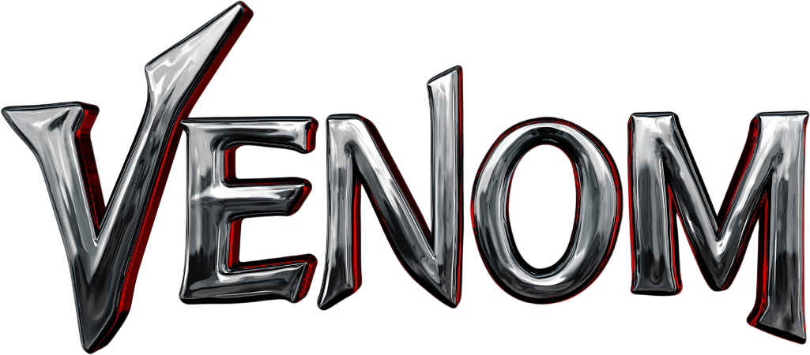

Dive into the darkness with Venom's Sinister Strength Workout, a workout designed to emulate the raw, relentless power of the infamous villain. Known for his extraordinary strength, menacing agility, and fierce determination, Venom is the perfect inspiration for those looking to tap into their hidden potential. Brace yourself to push past your limits and unleash the villain within.

1. Toxic Twists (Russian Twists): 3 sets of 20 reps
- Seated on the ground, lean back slightly, and twist your torso from side to side, holding a weight for added challenge.
2. Lethal Reverse Lunges (w/Bicep Curls): 3 sets of 10 reps each leg
- Stride backwards with force, imitating Venom's predatory movements, lift weights.

3. Nightmare Squat Kicks: 3 sets of 10 reps
- Squat down and with explosive energy come up and kick, mirroring Venom's agility.

4. Host Hops (Skater Jumps): 3 sets of 20 reps each side
- Leap from side to side, resembling Venom's swift, lateral movements.

5. Sinister Dips (Tricep Dips): 3 sets of 12 reps
- Channel Venom's fury by powerfully dipping towards the ground.

6. Symbiote Side Planks: 3 sets of 30 sec. each side
- Mimic the strength of Venom with powerful side holds.

Exercises: | Sets  Reps  Wt. | M | T | W | T | F | S | S
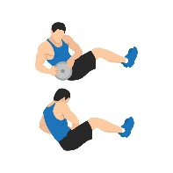  Russian  Twists | 3 sets
 | 20 reps
 | Wt.
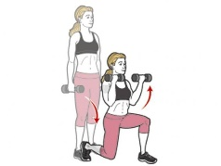  Reverse  Lunge w/  Bicep Curls | 3 sets
 | 10 reps
 | Wt.
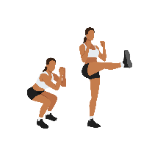  Squat w/  Alt. Front  Kicks | 3 sets
 | 10 reps
 | Wt.
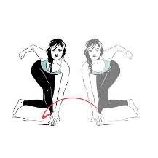  Skaters | 3 sets
 | 20 reps
 | Wt.
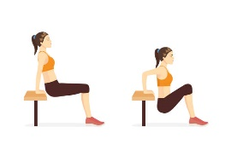  Tricep  Dips | 3 sets
 | 10 reps
 | Wt.
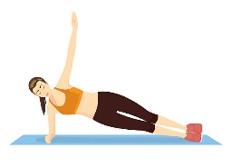  Side  Plank | 3 sets
 | 30 sec.
 | Wt.

You've triumphed over Venom’s Sinister Strength Workout, proving your strength and determination are a match for one of the most daunting villains. This workout has pushed you to your limits, but like Venom, you've emerged more formidable than ever. Remember, the strength you've tapped into today is a testament to your inner villain's might! Keep striving for greatness, and until we meet again, let the Venom within you thrive.

Name When Completed:

