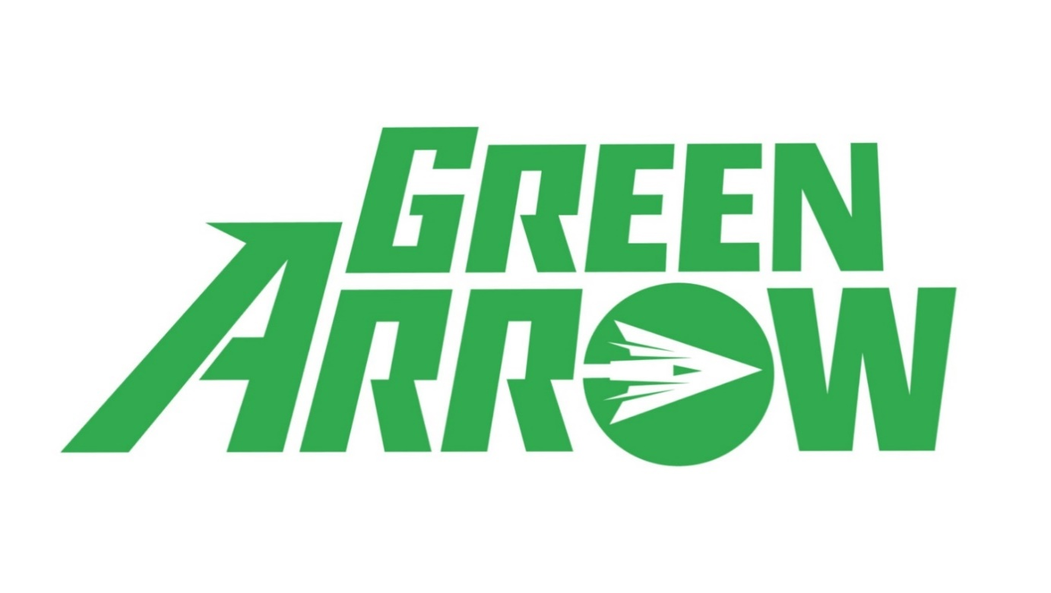

Welcome to the Emerald Archer's Precision Workout! Just like Green Arrow himself, this workout is designed to enhance your strength, agility, and accuracy. Get ready to unleash your inner superhero as we take aim at building a strong and toned physique.

1. Bent-over Rows: 3 sets of 15 reps
- Hinge at the hips, keeping your back flat. Pull the dumbbells up towards your chest, squeezing your shoulder blades together.

2. Reverse Flys: 3 sets of 10 reps
- Hold a pair of dumbbells in front of your thighs with palms facing each other. Keeping a slight bend in your elbows, lift the dumbbells out to the sides.
-
3. Dumbbell Lunges: 3 sets of 10 reps each side
- Hold a dumbbell in each hand at your sides. Step forward with one leg, bending both knees to lower your body towards the ground.

4. Plank with Shoulder Taps: 3 sets of 20 reps
- Start in a plank position with your hands directly under your shoulders. Tap your left hand to your right shoulder, then other side.

5. Dumbbell Side Lunges: 3 sets of 10 reps each side
- Hold one dumbbell in both hands. Step out to side and bend knee and come back to standing stance.

6. Pullover Leg Lift Crunch: 3 sets of 10 reps each side
- Lie on your back with one knee bent and other leg straight. Lift leg and crunch up with dumbbells.
Exercises: | Sets  Reps  Wt. | M | T | W | T | F | S | S
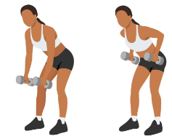  Bent-over  Rows | 3 sets
 | 15 reps
 | Wt.
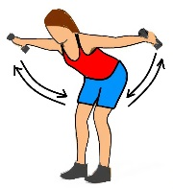  Reverse  Flys | 3 sets
 | 10 reps
 | Wt.
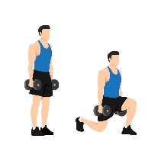  DB  Lunges | 3 sets
 | 10 reps
 | Wt.
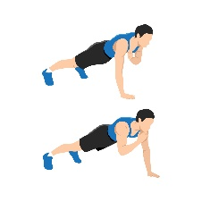  Plank  Shoulder  Taps | 3 sets
 | 20 reps
 | Wt.
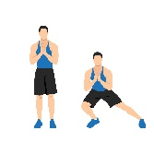  DB  Side  Lunge | 3 sets
 | 10 reps
 | Wt.
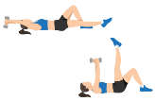  Pullover  Leg Lift  Crunch | 3 sets
 | 10 reps
 | Wt.

Congratulations, Archer! You've completed the Emerald Archer Precision Workout and are one step closer to superhero status. Keep practicing your skills, stay consistent with your workouts, and always remember to aim for greatness. Until next time, stay strong and keep aiming true!

Name When Completed:

